

Insurance Claims- Fraud Detection
Using Machine Learning
- Introduction:
For Auto Insurance industry, claim of fraud insurance is a huge problem. People usually give misleading information or sometime provide fake documentation to claim on their personal or commercial vehicles. It becomes very tedious task for Auto Insurance industry to identify whether claim is fraud or not. However, they tried hard to identify the genuine case and provide the benefit.

- Problem statement:
Insurance fraud is a huge problem in the industry. It's difficult to identify fraud claims. Machine Learning is in a unique position to help the Auto Insurance industry with this problem. In this project, a dataset is provided which has the details of the insurance policy along with the customer details. It also has the details of the accident on the basis of which the claims have been made.
With the help of given dataset our task is to build an appropriate model that detect auto insurance frauds and will help insurance industry for auto fraud detection.

- About Dataset:
- The dataset is available at Kaggle, GitHub.
- Dataset contains 1000 rows and 40 columns.
- The dataset contains policy_bind_year from 1991 to 2015.
- The incident_year in the dataset is 2015.
- Except one column ‘_c39’ no column contains null values.
- 21 out of 40 columns are of object type, 17 out of 40 are of int type, 2 out of 40 are of float type.

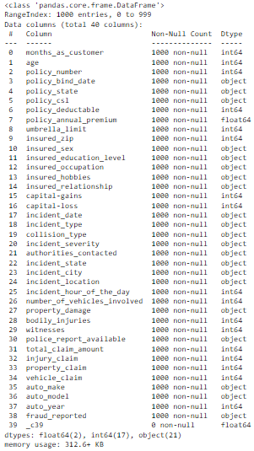

- Those columns in which all values are not present, contains unique or almost unique value in each row are unwanted columns. These unwanted columns are useless for machine learning model so drop it. In the given dataset ‘_c39’, 'policy_number', ‘incident_location' and 'insured_zip' are unwanted columns.
- Dataset is of small size. This problem is belongs to imbalanced classification problem.
- Imbalanced classification problem is a classification predictive problem in which number of samples in the dataset for each class is not balanced¹.

- Exploratory Data Analysis:
- Dependent Variable:

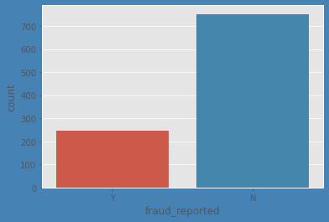
- From the above graph, dependent variable ‘fraud_reported’ has 247 out of 1000 cases reported as fraud case(y) and 753 out of 1000 cases reported as genuine case(n) i.e. 24.70 % cases reported as fraud. So, it is Imbalanced classification problem.

- Data Visualization:

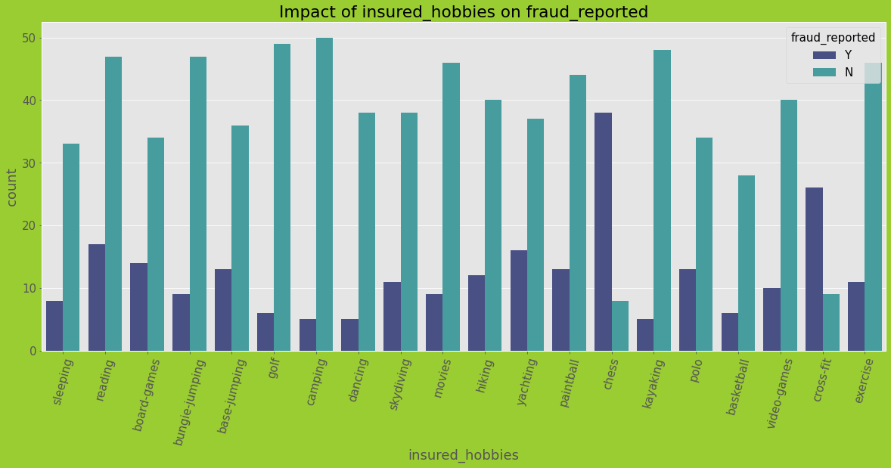

- Outcome: The customers with hobbies as chess and cross-fit have high tendency of fraud.

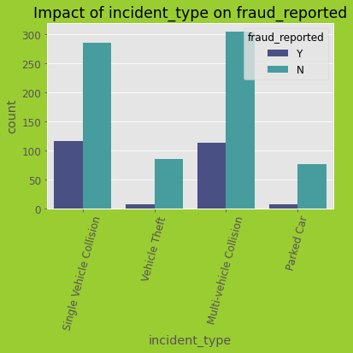

- Outcome: High rate of fraud in case of Single Vehicle Collision and Multi-vehicle Collision as incident_type.

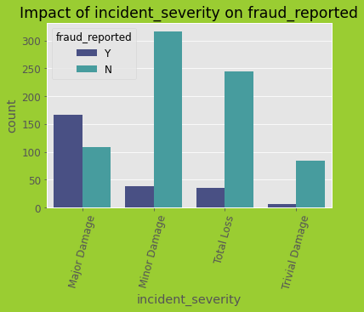

- Outcome: High rate of fraud is reported in case of Major Damage as incident_servity.

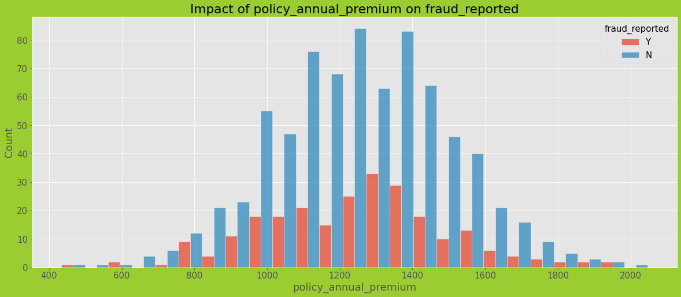

- Outcome: High fraud noticed when policy_annual_premium is between 1200 to 1400.

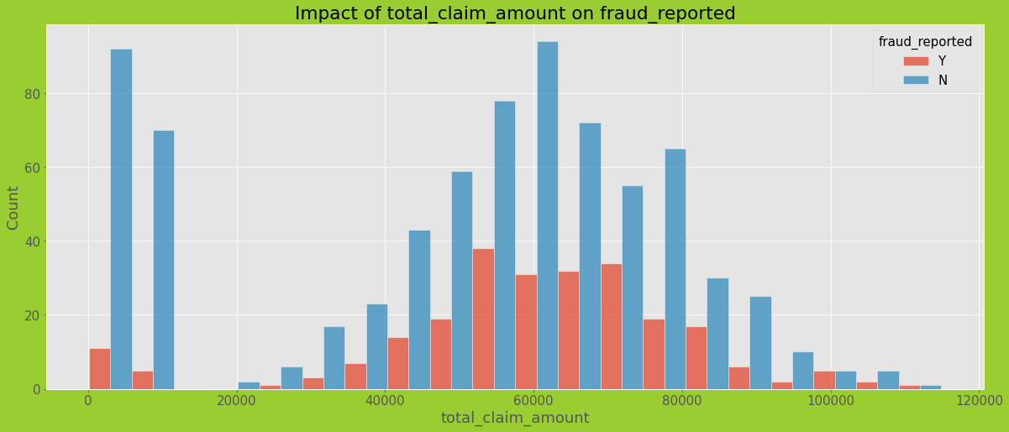

- Outcome: High Fraud noticed when total_claim_amount is between 4000 to 8000.
- Correlation matrix to see the coefficient of multicollinearity:

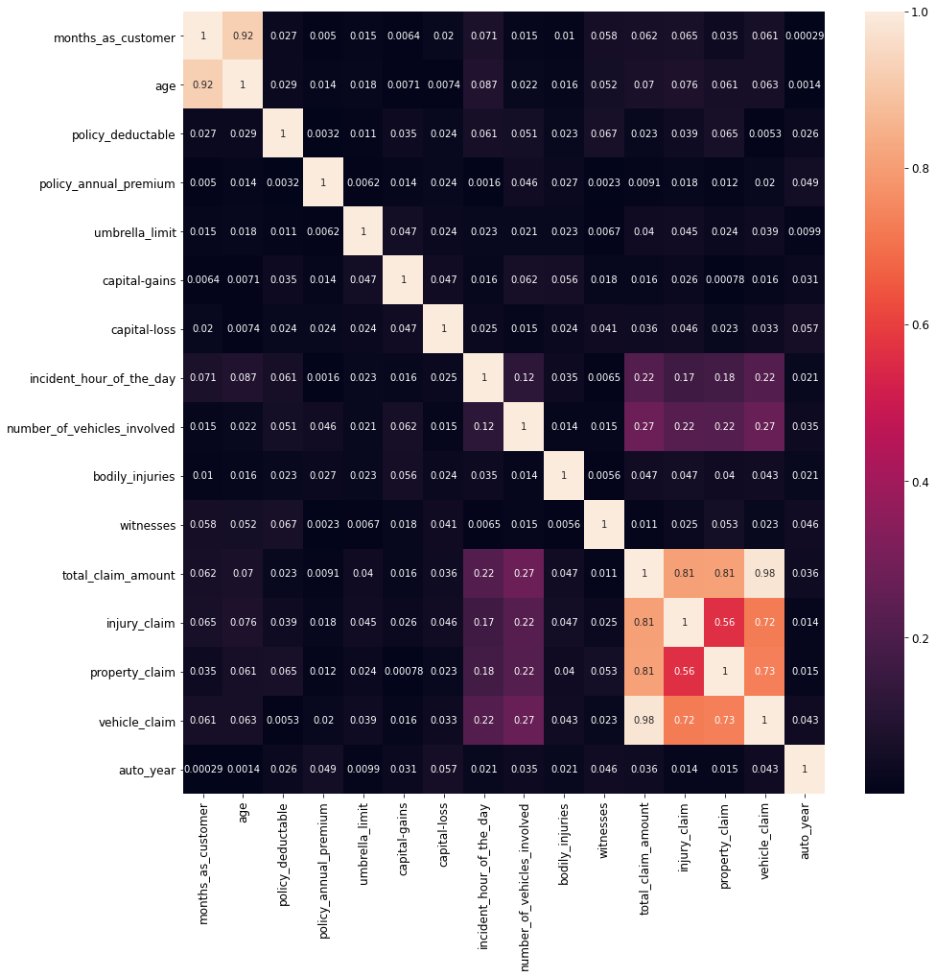
- Multicollinearity occurs when two or more independent variable highly correlated with one another. It affects the performance of model. Features that are highly correlated to each other are:
- months_as_customer and age.
- total_claim_amount, vechile_claim, property_claim, and injury_claim.

- Data Pre-processing:
- Data pre-processing includes:
- Treating null values: However, now this dataset does not contain any null value. If there is null value in the dataset, null values can be treated by different technique. Few techniques are:
- Deleting rows that contains null values.
- Imputing missing values for continuous column by mean, median and for categorical values by mode.
- Different Imputation methods.
- Predicting the value for missing values.
- Using algorithm which support missing values.

- Feature Extraction: Feature extraction refers to the process of transforming the data into numerical feature. 'policy_bind_date' and 'incident_date' are those columns from which we will have to extract Day, Month and Year.

- Data Cleaning: Data cleaning refers to the process of identifying incorrect, incomplete, inaccurate, irrelevant part of the data and then modifying, replacing or deleting accordingly. 'property_damage', 'police_report_available' and collision_type' contain irrelevant data as ‘?’ so, need to replace it. One row contains negative value in 'umbrella_limit' so need to drop it.

- Descriptive Statistical Analysis:
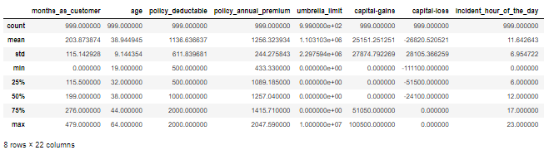
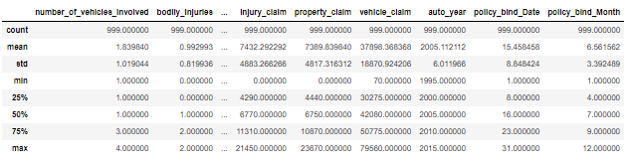
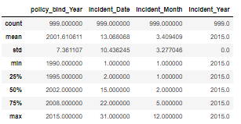

- The difference between mean and 50 % shows that there is skewness in dataset.
- The huge difference between 75 % and max shows that there is outliers in dataset.

- Features Engineering:
- Dealing with outliers:
Outliers are data that is different from others.
- There are different techniques to deal with outliers like IQR method, zscore method.
- In the dataset, the columns that contain outliers are: 'age', 'umbrella_limit', ‘property_claim', 'total_claim_amount', 'incident_Month'.
- To deal with these outliers z-score is used which is member of stats in scipy.

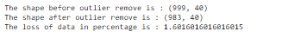

- Dealing with skewness:
Skewness refers to the measure of how much the probability distribution of a random variable deviates from the normal distribution². Different type of skewness is Left, Right, Symmetric skewness.
- There are different technique to deal with skewness:
- Log transformation
- Normalize
- Cube root
- Square root etc
- In the dataset some skewness is present.
- For this dataset, Skewness will be treated +/-0.5. The skewness of categorical and target variable will not be treated.
- ‘yeo-johnson’ method of Power Transformer is used to deal with skewness.

- Encoding categorical column: As machine learning model understands numerical values or we can say that for a good model we need data in numerical form. To deal with this, machine learning has different type of encoder which converts object type of columns/variable into numeric by encoding them or we can handle it by replace/custom mapping.
- Few encoding techniques are:
- Label Encoding
- Ordinal Encoding
- One Hot Encoding
- Dummy Encoding
- Binary Encoding
- Label encoder is used for encoding categorical variable.

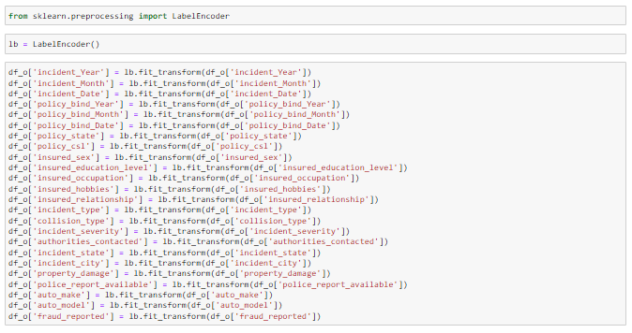

- Scaling the independent variable: Scaling is a method to normalize independent variable. In machine learning different technique are available to normalize the data.
- Few techniques used for scaling:
- Absolute Maximum Scaling
- Min-Max Scaling
- Standardization
- Before scaling select fraud_reported as y as dependent & rest are as X as independent variable.
- After selecting X and y, Standard Scaler is used to scale independent variable.

- Dealing with multicollinearity: The best way to deal with multicollinearity is VIF. VIF is variance inflation factor which is member of stats.outliers_influence of statsmodels.
- For each feature calculate VIF score and try to drop those independent features which have highest VIF. Check VIF again.
- The standard threshold for VIF is 5. However, sometimes it depends upon the dataset.
- In the given dataset, total_claim_amount has highest Vif followed by vehicle_claim, injury_claim, property_claim. So, after dropping total_claim_amount there is no multicollinearity problem exist in the dataset.

- Dealing with imbalancing: The best way for balancing the dataset is SMOTE algorithm.
- SMOTE algorithm works on two method oversampling or under sampling.
- Oversampling: Based on given data create new entries for the minority class.
Under sampling: Based on given data randomly delete entries for the minority class.
- Oversampling is used for dealing this imbalancing present in target variable.

- Machine Learning Model:
- There are several machine learning models available in sklearn library for regression and classification problem.
- The target variable ‘fraud_reported’ contains two values whether the claim is fraud or not. So, the problem is binary classification problem.
- Before fit the dataset, split the dataset using Train Test Split.
- Train Test split is a mechanism by which we can split our dataset into train and test set.
- In this project dataset is split into 70:30 ratio i.e. train set contains 70% data on which model is going to be trained and test set contains 30% data on which trained model makes prediction.
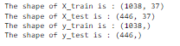

- In this project 9 machine learning models are selected. The models are:
- Logistic Regression
- K-Neighbors Classifier
- Decision Tree Classifier
- Random Forest Classifier
- Support Vector Machine Classifier
- Bagging Classifier
- Gradient Boosting Classifier
- Ada Boost Classifier
- XGB Classifier

- Initiate the model:
- Logistic Regression:
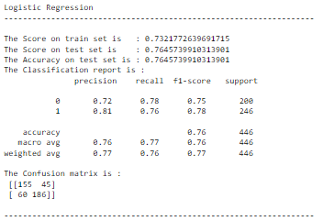
- Cross Validation
- K-Neighbors Classifier:
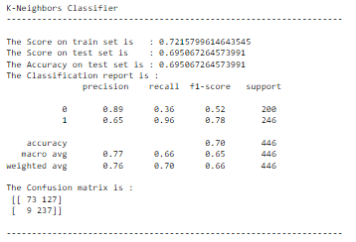
- Cross Validation

- Decision Tree Classifier:
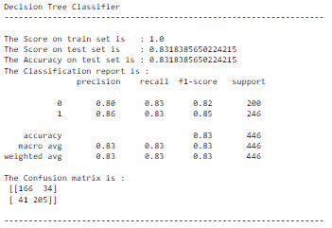
- Cross Validation

- Random Forest Classifier:
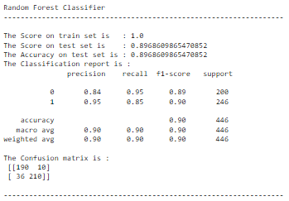
- Cross Validation

- Support Vector Machine:
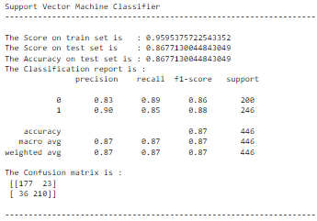
- Cross Validation

- Bagging Classifier:
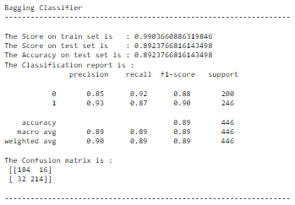
- Cross Validation

- Gradient Boosting Classifier:
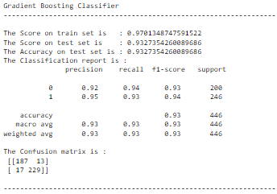
- Cross Validation

- AdaBoost Classifier:
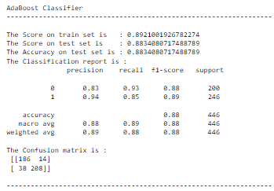
- Cross Validation

- XGB Classifier:
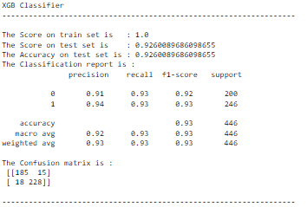
- Cross Validation

- ROC Curve: An ROC curve is a graph showing the performance of classification model at all classification thresholds³.
- The curve plot two parameter:
- True Positive Rate
- False Positive Rate
- Here is the graph for all model
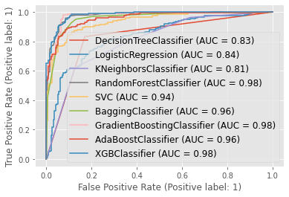
- From above graph Random Forest Classifier, Gradient Boosting Classifier, XGB Classifier have best score.

- Observing Score of all model:
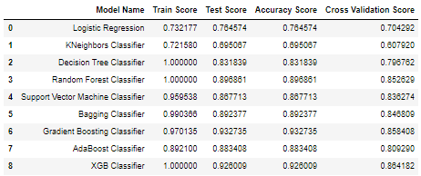

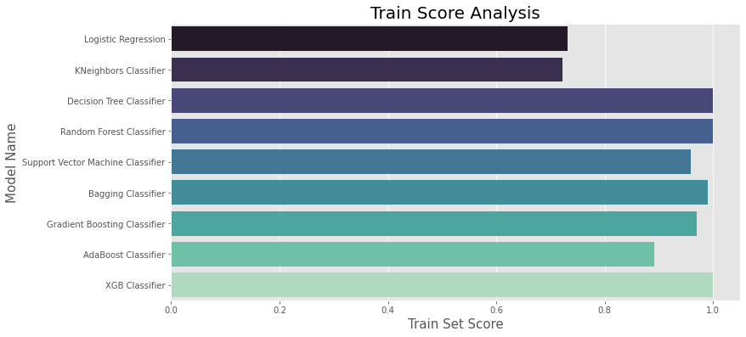
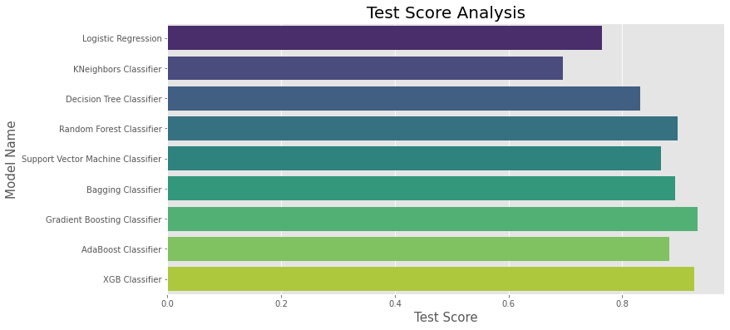
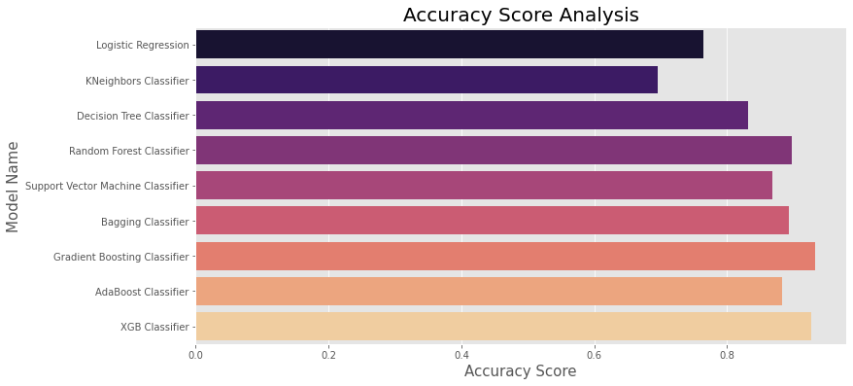
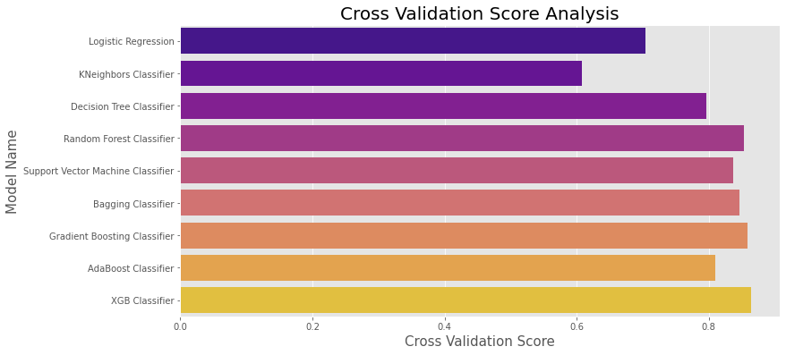
- Random Forest Classifier, Gradient Boosting Classifier and XGB Classifier all model are good as they gives better accuracy. The difference between accuracy and cross validation score is Random Forest Classifier which has less score. F1 score is 0.85. So, Random Forest Classifier is best model.
- Hyperparameter Tuning: The Hyperparameter tuning is a technique of choosing optimal hyperparameter for learning model. Hyperparameter is a parameter which value is used to control the learning process⁴. The objective of hyperparameter tuning is to improve the performance of model. It also observed the result of hyperparameter tuning is not always improving the performance of model.
- Different technique also available for hyperparameter tuning. Few techniques are:
- Random Search: Based on a random search on hyperparameter.
- Grid Search: Based on an exhaustive search on hyperparameter.

- Here Grid Search CV is used on Random forest classifier for Hyperparameter Tuning.

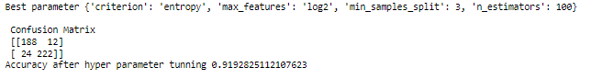

- After hyperparameter tuning, the model performance is improved.
- Fit the model using these hyperparameter and save the model.

- Load the model and see prediction: Loading the saved model and observe how well this model is predicted on test set.

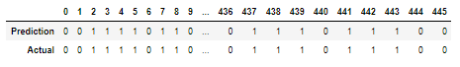

- Conclusion:
- The objective behind building this model is to detect the fraud automatically to help auto insurance industry in eliminating the frauds.
- This model will also help in economic growth of insurance industry.
- The term growth is used because if a model is able to detect auto fraud then it will help in reducing finical loss and there will be economic growth in insurance industry.
- Nine different models are used for this classification problem.
- Data imbalancing is most general problem found in classification dataset. To handle imbalancing, SMOTE is used by oversampling the data.
- Standardization and Train Test split are used to normalize and split the dataset respectively.
- In this project, the best performing model on given dataset is Random Forest Classifier.
- Accuracy of model is 89.68%, ROC AUC score is 0.98 and f1 score is 0.85. Difference between Accuracy and CV score is less as compared with other best model. All metric are good as compared with other model. Basically, good metrics are the criteria for best model.
- Limitations of this model are small size of dataset, ‘incident_date’ contains few month data for only year 2015 which is not enough to build an appropriate model.

- References:

- https://machinelearningmastery.com/what-is-imbalanced-classification/
- https://www.analyticsvidhya.com/blog/2020/07/what-is-skewness-statistics/
- https://developers.google.com/machine-learning/crash-course/classification/roc-and-auc
- https://www.analyticsvidhya.com/blog/2021/04/evaluating-machine-learning-models-hyperparameter-tuning/

Written by: Rohit Kachhal

